*Where needed assume g, the gravitational field strength on earth, = 9.8 N/kg*

**1** **a)** What is the definition of a vector quantity? (2)

**b)** Which two of these quantities is a scalar quantity?

displacement  speed  temperature  velocity  force (2)

**c)** The distance travelled in a defined direction is called a ……………. and is a  
 ……………… quantity. (2)

**d)** Identify the following forces as contact or non-contact forces.

Air resistance

Tension

Magnetic                                (3)

**2** **a)** A mouse has a mass of 20 g. How much does the mouse weigh on Earth? Express your answer in N. (2)

**b)** What would the mouse weigh if it were on the Moon where gravitational field strength is 1.6 N/kg? (2)

**c)** Is the mass of the mouse higher, lower or the same on the Moon? (1)

**3** **a)** A tennis ball is dropped out of a first floor window. What two forces act upon it as it falls to the ground? (2)

**b)** Is air resistance acting in the same direction as gravity? Explain your answer. (2)

**c)** In the diagram below a force of 3 N is pushing the object to the right and a force of 4 N is pushing the object to the left. The resultant force is 1 N to the left.

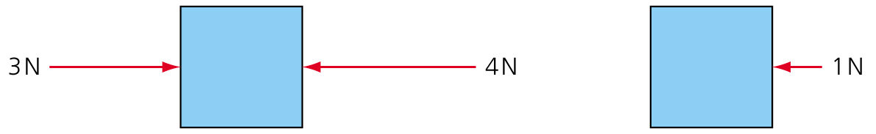

Draw the resultant force arrow in each of the following diagrams.

**i)**

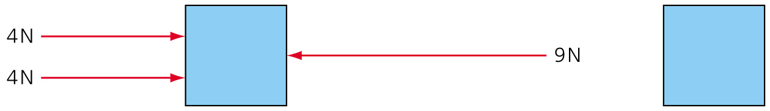

**ii)**

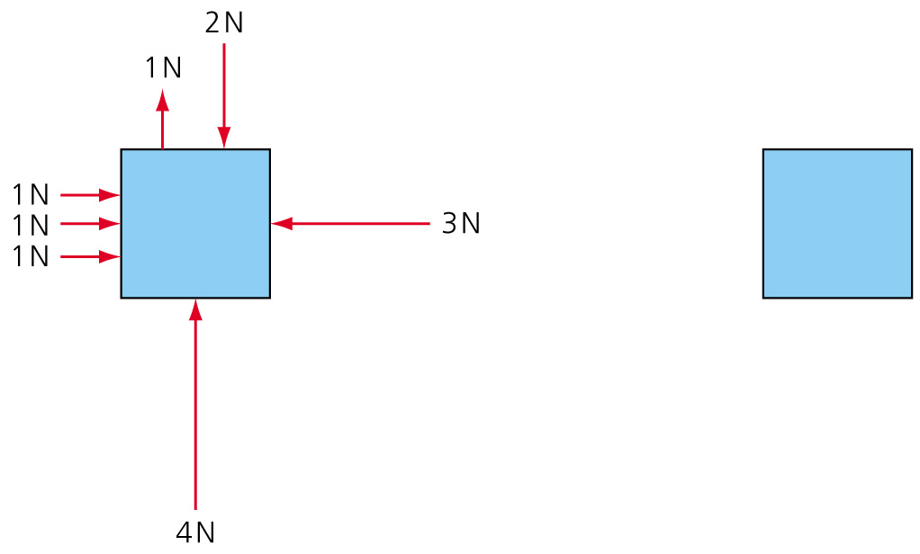

**iii)**

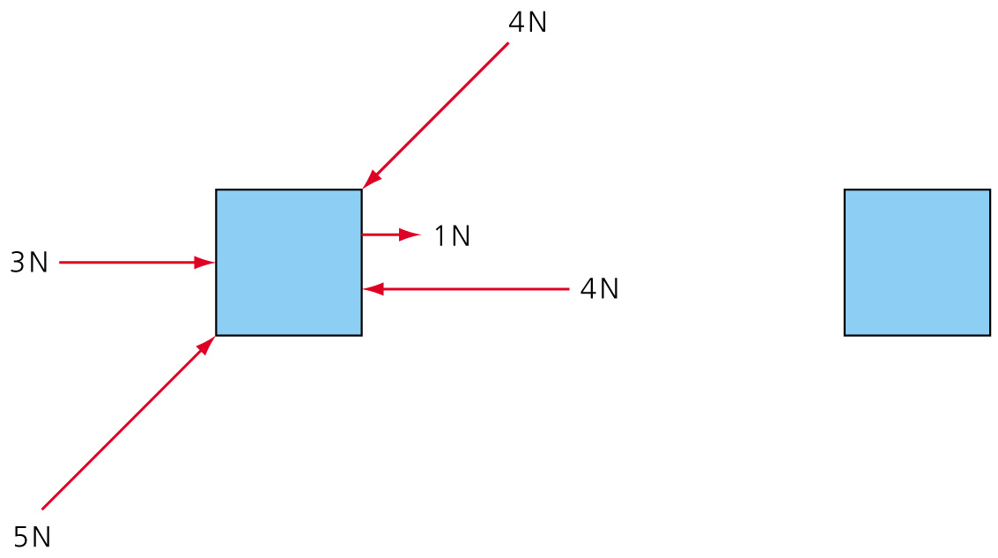 (3)

**4** **a)** Insert the correct words into the spaces in the sentence.

One …………… of work is done when a force of 1 ……. moves an object a distance of 1 …….. . (3)

**b)** Andy the astronaut is standing on the surface of the Moon. He has a weight on Earth of 980 N when in his spacesuit. What is his mass on the Moon? (On Earth *g* = 9.8 N/kg). (2)

**c)** Andy lifts a moon rock from the Moon’s surface into the lunar module storage area. The rock weighs 72 N on the surface of the Moon. The storage area is 1.5 m above the Moon’s surface.

**i)** If the gravitational field strength of the Moon is 1.6 N/kg what would the moon rock weigh on Earth? Express your answer in newtons. (2)

**ii)** Calculate how much work Andy does to put the rock into the lunar module. (2)

**iii)** Calculate the increase in gravitational potential energy of the moon rock when it is moved from the surface to the lunar module storage area. (2)

**iv)** What percentage of Andy’s weight (including his spacesuit) is the weight of the rock when they are both on the Moon? (2)

**v)** What is the mass of the moon rock on Earth? (1)

**5 a)** A dog with a mass of 30 kg stands on the Earth’s surface. The area of each paw in contact with the ground is 4 cm2. Calculate the pressure the dog exerts on the ground when it is standing on all paws. Express your answer in N/m 2. (2)

**b)** If the dog was standing on the Moon, would the pressure exerted on the surface of the moon be higher or lower than on Earth? Explain your answer. (2)

**6** Explain what is meant by the terms elastic and inelastic deformation. (2)

**7** Susan wants to calculate the weight of a melon she has just bought.



She puts the melon in a spring balance, as shown. The spring constant is 200 N/m.

**a)** What is the weight of the melon, expressed in newtons? (2)

**b)** Susan adds an orange to the basket and the spring extends by a further 2 cm. What is the weight of the orange, expressed in newtons? (2)

TOTAL = 45

**1** **a)** A quantity that has a size and a direction. (2)

**b)** Speed; temperature (2)

**c)** The distance travelled in a defined direction is called a **displacement** and is a **vector**quantity. (2)

**d)** Air resistance   **contact**

Tension      **contact**

Magnetic     **non-contact** (3)

**2** **a)** 20 × 10–3 × 9.8 = 0.196 N (2)

**b)** 20 × 10–3 × 1.6 = 0.032 N (2)

**c)** The same (1)

**3** **a)** Gravity; air resistance (drag). (2)

**b)** No; air resistance reduces the pull of gravity and therefore must be acting in the opposite direction. (2)

**c) i)**

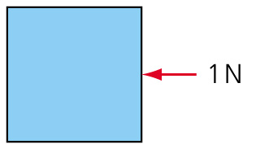

**ii)**

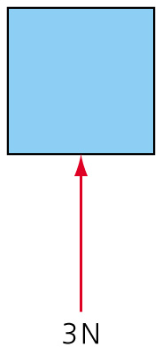

**iii)**

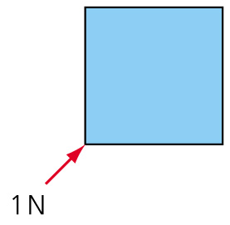 (3)

**4** **a)** One **joule** of work is done when a force of 1 **newton** moves an object a distance of  
1 **metre**.(3)

**b)** Weight = mass × *g*;

mass =  = 100 kg. (2)

**c) i)** Mass of rock =  = 45 kg;

weight on Earth = mass × *g* (Earth) = 45 × 9.8 = 441 N. (2)

**ii)** Work = force × distance = 72 × 1.5 = 108 J. (2)

**iii)** Increase in gravitational potential energy = *m* × *g* (moon) × *h*

= 45 × 1.6 × 1.5 = 108 J. (2)

**iv)** Andy’s weight on the Moon is 100 × 1.6 = 160 N weight of moon rock is 72 N therefore percentage =  × 100 = 45% (2)

**v)** Mass = 45 kg (1)

**5** **a)** Pressure = ; force = (30 × 9.8) = 294 N area = 4 × 4 × 10–4 = 1.6 × 10–3  m2. Therefore, pressure = 183750 N/m 2 (2)

**b)** Lower than on Earth. The weight of the dog is lower because the gravitational field strength of the moon is lower than on the Earth. Assume that the paw size is the same so the pressure is lower. (2)

**6** When something is elastic, it will return to its original shape when the force stretching/deforming it is removed. If it is inelastic, it will not return to its original shape.         (2)

**7** **a)** Force (weight) = spring constant × extension = 200 × 0.06 = 12 N (2)

**b)** Force (weight) of melon plus orange = 200 × 0.08 = 16 N, therefore weight of orange   
= 16 – 12 = 4 N (2)

TOTAL = 45